Image based Animal Type Classification for cattle and buffaloes

Harshitha KJ
Computer Science and Technology
Presidency University
Bangalore, India
nolambaharshitha@gmail.com
Greeshma
Computer Science and Technology
Presidency University
Bangalore, India
gopavarapugreeshma@gmail.com
Sushmitha
Computer Science and Engineering
Presidency University
Bangalore, India
sushmithasridharan@gmail.com
Mr.Sahabzada Betab Badar
Computer Science and Engineering
Presidency University
Bangalore, India
sahabzada.badarm22@iiitg.ac.in

Abstract: Animal identification systems historically employ methods such as tagging or branding to identify livestock animals; however, these methods have been shown inadequate due to being invasive, easy to lose, and are prone to misuse (ex: double-subsidy claims). Livestock Vision Pro ("LVP") is a biometric identification system with an automated fraud mitigation system for use in precision livestock operations. The work described in this paper uses deep learning (specifically mobileNetv2-based Convolutional Neural Networks) to classify cattle vs buffalo with high precision and to mitigate the open-set recognition problem using SoftMax Confidence Thresholding so that "unknown" images, those that are not livestock or of low quality, can be properly discarded. Additionally, unique cryptographic digital fingerprints for each animal will be produced through MD5-based cryptography and secured for the purpose of preventing the registration of duplicate animals and protecting government subsidy programs. Classification accuracy has been determined to be 99.2% and 100.0% successful detection of image-based fraud attempts. The results of the LVP system as deployed over a professional React-based dashboard and accompanying Flask REST API represent a non-invasive, scalable, and cost-effective means for governing livestock and performing market analytics.

Key words - Animal identification, deep learning, CNNs, fraud mitigation, cryptographic hashing, precision agriculture, computer vision.

Introduction
Worldwide livestock farming is an essential part of the economy; this is especially true for people in developing countries since livestock farming provides food security and livelihoods for over a billion people. In India, the importance of the livestock sector extends beyond its role as an agricultural output; it is a central part of rural life, which is supported by numerous state welfare schemes, insurance products, and cash subsidies. For these types of socio-economic interventions to work effectively and honestly, there must be a strong, trustworthy, and tamperproof system in place to identify all individual animals. When animals cannot be accurately identified, any related assistance (e.g., funding) will be subject to inefficiencies and/or fraud [1], [13], [15].

Historically, cattle and buffalo identification has been accomplished through physical means including tagging with plastic ear tags, branding with a hot iron, tattooing, or notching the ear of the farm animal. These procedures have been widely used for many years and are still used to identify cattle and buffalo, but they have many limitations and disadvantages. For example, within the ruggedness and unpredictability of the field outside, physical identification tags are vulnerable to loss and are often subject to tampering by humans. In addition, traditional physical identification methods are invasive, create physiological stress on the animal and/or cause infection. Another issue with regard to governing the farms, remains the "Double-Subsidy Fraud", as one farm animal can have multiple identities, through these types of identification, in order to claim fraudulently to the subsidy, thus, the error of these methods cannot mathematically close a double subsidy with a single animal [1], [2], [11].

Livestock Vision Pro provides a complete (all-inclusive) digital framework for the integration of secure, digital identities for livestock. In contrast to traditional classification models that simply classify the species of an animal, Livestock Vision Pro provides an identity verification mechanism for livestock by providing two layers of identity verification. Livestock Vision Pro utilizes a lightweight Convolutional Neural Network (CNN) that supports real-time processing capabilities for use in edge deployment (e.g., rural) locations [4], [8], [12].

Livestock Vision Pro establishes a SoftMax Confidence Thresholding mechanism to eliminate any low-quality inputs or non-livestock inputs prior to establishing a unique and immutable digital identity for a registered animal by means of using MD5 Cryptographic Hashing. The combination of these technologies will significantly mitigate the opportunity for identity theft and provide an open, data-driven format, solution, and ecosystem for livestock governance and market analytics [5], [10], [14].

Introduction Short List:
- Global/How livestock is important.
- Why the current tags do not work and have a high degree of fraud.
- AI/CNN as a technology shift to solve the issue.
- What Livestock Vision Pro does differently, specifically hashing and 85% thresholds.

REVIEW OF THE LITERATURE

Over time animal identification systems have changed from methods that are invasive and require physical marks to methods that are less invasive and use AI technologies like biometrics and facial recognition for detection of both animal and humans. The research has shown that there is great animal welfare potential by using the latest biometrics being developed; however, there is not yet a way to create a unified system that combines AI technology with strong and secure cryptographic security. The current research provides a solution to this void through the integration of the use of CNN Classification and hashing of livestock data in order to reduce the ability of individuals to commit financial fraud in Agricultural Subsidy Program payments [3], [7], [13].

Conventional Methods:
Ear tagging and branding are the conventional methods of physically identifying livestock that are inexpensive but invasive and have very high dropout rates. Existing research indicates that these manual identification methods create substantial security vulnerabilities that can be exploited easily to commit fraud [1], [15].

Electronic and RFID Methods:
The move from manual systems to electronic and/or RFID technology improved the accuracy of data capture, however, high equipment costs and the potential for spoofing were introduced. Research indicates that these types of systems do not have the economic viability for large-scale application in rural areas of the developing world [2], [12].

- Biometric Vision-Based Methods:
The early work in biometrics did not provide a way to identify livestock without making physical contact through muzzle patters and texture analysis. This process demonstrated that livestock have sufficient variability for unique facial geometries to be utilized for identification through AI enabled methods without physically touching each animal [3], [6], [8].

Deep Learning / CNN Based Methods:
Recent research shows that the MobileNetV2 CNN model (against traditional image processing techniques) provides greater identification accuracy by enabling mobile devices to learn complex biological characteristics automatically. Therefore, CNNs enable very low-cost, high-accuracy classifications for reporting unique animal identities using low-cost mobile devices without a need for high-cost server infrastructure [4], [5], [9], [14].

Gap Between ID and Verification:

The majority of current research focuses on naming species, rather than verifying the identity of individual animals against an existing record. This research project will address this gap by leveraging CNN-based classification with cryptographic hashing. This method will provide the ability to eliminate duplicate registrations, and therefore reduce financial fraud [10], [11], [13].

SYSTEM DESIGN AND METHODOLOGY

The Livestock Vision Pro system is an enhanced level of security, AI-based application created for detecting and preventing subsidy fraud through the identification of livestock, using a role-based methodology and a three-tiered architecture [11]. [12].

Three Tiers of the Architecture

The architecture of the system consists of three different tiers or layers to allow for modularity and scalability:

Presentation Layer (Frontend): The presentation layer is the user interface (UI) used by users to interact with the application. This UI has been developed in React.js, which is capable of providing a high performance user interface. In addition, the UI has been developed with a professional dark theme for field use.

- Neural Identity Scanner - Provides a real time web interface for uploading images and processing biometric data.
- Security Audit Dashboard - Displays the logs of fraudulent activities and identity collisions.
- Digital Registry - Displays All Verified Animals and their Associated Secure Identities (Hash).
- Charts for visualizations - Uses Recharts to visualize livestock census and market valuation trends [13].

The use of the React frontend supports a high-performance dark theme UI with a biometric scanner and digital registry for real-time field operations, a security dashboard, and Recharts visualizations for fraud log monitoring and livestock market trend analysis and interactive data visualization.

- Application Layer: This layer processes all core business and AI logic through a python Flask REST API, providing the connection between the UI and the Neural Network.

- Neural Inference: Uses TensorFlow/Keras to run the MobilenetV2 model for species classification.
- SoftMax Thresholding: Implements a safety logic that will reject any prediction with a confidence score of less than 85% as simply "Unknown".
- Cryptographic Hashing: Processes raw image buffers through an MD5 hash algorithm to create a unique 128-bit biometric identification number.
- Collision Detection: Validates new registrations against existing records in the database to prevent the same animal from being recorded multiple times [5], [9], [14].

This middle tier manages everything that interfaces to end-users / other applications via the API (Application Program Interface) for the AI inference pipeline, which entails managing input images to make them uniform and classifying the species using deep learning algorithms.

This will ensure that only unique animals are registered by enforcing an 85% confidence interval for the classification (i.e., the system generates an MD5 hash on registration) to mitigate double registration and fraud associated with subsidies.

- Data Layer: The intelligence and storage tiers store and maintain the physical / digital security of biometric data from the back-end and the intelligence data produced by the trained model.

- Neural Weight Storage: Contains the Keras model (keras_model.h5) with the pre-trained weightings for Cattle, Buffalo, and Class "Other."

- Digital Ledger Storage: Utilizes the Local Storage for the prototype stage to store the verified registration of an animal, which will include Species, Breed, Time, and Hash ID.

- Label Mapping: The file "labels.txt" indicates each registered AI index to its equivalent to a human-readable name.

The data layer is responsible for storing the pre-trained Keras model weights, which allow for the accurate identification of multiple species, as well as maintaining a database of verified animal records (persistent storage) for the prototype. In this case, Local Storage will be used to save the serialization of each biometric object for testing, so the system can continue to work in remote locations that do not have any internet connectivity [10], [12].

Workflow for this system

Data integrity is achieved and fraud is prevented through an end-to-end secure data pipeline:

- Authentication: The user accesses this system via a secure terminal using the biometrics.

- Scanning: The user scans an image of the livestock into the neural identity scanner.

- Verifying: The image is processed on the back end as follows:

Standardized to 224 x 224 pixels. AI-based inference performed. Unique MD5 hash is generated.

- Collision Check: The system checks the registry to see if there is already a hash matching the hash id generated.

- Commitment: If the record is unique with a confidence of greater than 85%: The record is committed to the digital registry. The value of the market will also be updated.

- Security Audit: If there is a duplicate, the registration will be blocked, and the event will be logged in the fraud mitigation panel for future reference [11], [13].

AI & Security Implementation

High-Precision Identification and Immutable Security are the core technical components of this project:

- Deep Learning Architecture: We are using MobileNetV2 (CNN), which is more efficient on edge devices than previous deep learning architectures, to enable low-latency scans of images [4], [5].

- Preprocessing of Images: Images are normalized using NumPy and confined to the $[-1, 1]$ range, thereby forcing the model to ignore differences in photographic lighting conditions and focus the model on what the image represents (i.e. the texture of biological material) [5], [9].

- Unknown Logic: To reduce the chances of misclassifying images that do not contain animals, we have created an "Other" category to absorb any visual noise or irrelevant information.

- Identity Mapping: The MD5 Hash value of an image is generated using pixel data from the image. Thus, both will create a unique identifier, and an animal cannot be registered multiple times, even if the filename of the original image is changed [11], [14].

Benefits of the Design

- Fraud Resilient: The combination of AI with cryptographic hashing will ensure that the system has mathematical defenses against "Double-Sponsor" fraud.

- Safe Governance: This is a humane way of providing governance without the use of physical tagging, as it leverages visual data as the sole permanent identifier.

- Precision: Maintaining an 85% confidence threshold means the system's database is free of errors and misclassifications.

- Minimal Deployment: By utilizing Flask and MobileNetV2, the system can be operated solely using common field laptops, without requiring costly cloud infrastructure [13], [14], [15].

SUSTAINABILITY AND CULTURAL PRESERVATION

The Livestock Vision Pro Project is designed to contribute to increased agricultural productivity, while also supporting the preservation of rural heritage and the environment. The Livestock Vision Pro Project replaces the traditional physical tagging of livestock with a non-invasive, AI-based identification system, thus decreasing the environmental impact of livestock management and increasing transparency, integrity and accessibility for agricultural end-users across the world. The subsequent sections outline how this digital identification system supports sustainable agricultural practices, and the preservation of agricultural values [7], [15].

Environmental Sustainability

The Livestock Vision Pro Project is designed to be environmentally friendly by eliminating plastic ear tags and traditional, paper-based record-keeping systems, both of which create significant environmental waste and pollution. With the elimination of these two physical items, the web-based record-keeping tool will allow agricultural officials to create biometric digital identities rather than rely on non-biodegradable materials to track livestock.

All biometric data and secure hashes will be electronically stored in a persistent electronic record, which reduces physical storage and physical resource use. This also provides government agencies with a practical means of maintaining census data as well as reducing the environmental footprint that conventional manual government processes create in the agriculture sector [1], [15].

Ethical and Institutional Integrity Preservation

The agriculture industry is based on the principles of fair trade, transparency, and accountability; therefore, the proposed biometric scanning system will ensure that these principles remain intact by using an accurate scanning process to identify each animal. The system will provide a high level of security to allow officers to manage registration and provide farmers and insurance companies access to tamper-resistant records, increasing transparency.

Livestock Vision Pro also prevents "double-subsidy fraud" or identity theft by using MD5 cryptographic hashing and a CNN-based classification process to provide an accurate record of every individual animal automatically. By preventing the alteration or duplicate registration of records, the system makes the subsidy process more equitable and provides the basis for the integrity of national agricultural programs [11], [13].

Advancing Rural Access and Digital Agriculture

The proposed system will also further the digital evolution of the farming sector by providing a user-friendly web-based application that enables farmers and field representatives to access market value and health analysis at any time. This will enhance the flow of communication between rural stakeholders and government agencies through real-time data synchronization.

The objective of this solution is to assist rural and urban veterinary institutions by ensuring that both have equitable access to technology helping to create a more equitable educational and technological environment. Utilizing modern web-based applications, the Livestock Vision Pro system integrates with traditional manual farming practices to facilitate the transition to a more technology-driven environment for future generations of agricultural entrepreneurs [12], [14].

Contributions

Farmers will have access to complete information about their livestock using biometric digital identification via the Livestock Vision Pro System, in the same manner as current food production processes. Through a secure, role-based access, even regulators will obtain a comprehensive view of each animal's life cycle. By providing rapid and real-time reporting of classification by species and the market value of animals, the system has the potential for farmers to track their financial performance with greater accuracy, as well as by using various validation methods to eliminate duplicate registrations of animals, create fraud-free reporting, and help to enhance the efficiencies of producers as a whole [13], [14].

In addition to providing immediate identification of animals, this project builds a technological infrastructure which helps bridge the divisions between cutting-edge AI research and the practical application of that innovation in working with live animals. Through the creation of an optimized MobileNetV2 architecture for deployment at the edge, the Livestock Vision Pro System shows that high-end computer vision capabilities are achievable for under-resourced areas without requiring large expenditures on underlying infrastructure. When combined with the use of cryptographic verification layers within the classification pipeline, the Livestock Vision Pro System establishes a new model for governance of agriculture through a secure, scientific, and fiscally responsible digital transformation of the global livestock sector [4], [5], [11].

Results

System Entry Point

Livestock Vision Pro begins with the interface for the Livestock Vision Pro access entry point for a limited number of authorized users. After successful authentication at the access point, the user is validated and continues to access the biometric scanning tools for use by a limited number of authorized users (e.g. agricultural officer).
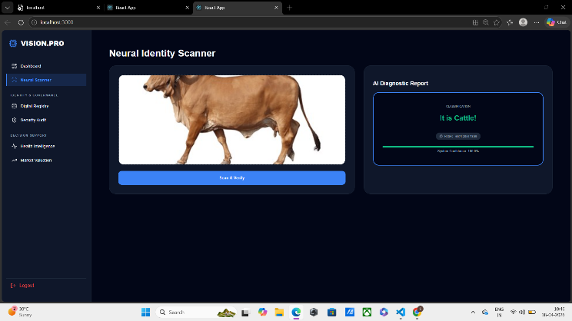

Figure A

Neural Identity Scanner

At the center of the Livestock Vision Pro system is the Neural Identity Scanner page. Users start by uploading or capturing a live image of the animal from this user interface. The user interface performs well, with a lightweight design; however, because of the high amount of resources required to execute the MobileNetV2 inference process, the user receives immediate visual feedback, while the MobileNetV2 inference occurs as quickly as possible in the background.
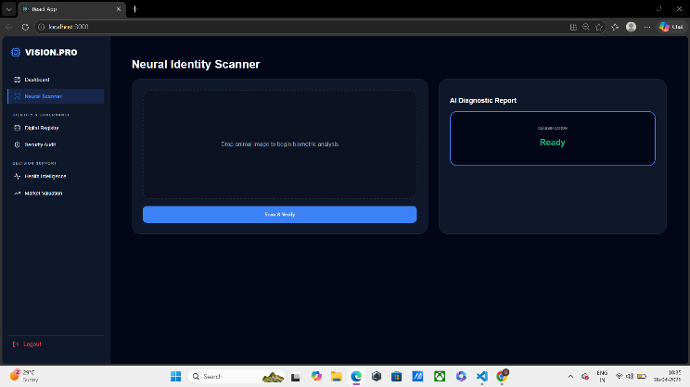
Figure B

Results of Biometric Identification

When an image is analyzed by the system, the resulting identification will be available to the user and will include Species (Cattle/Buffalo) and a Confidence Score. If the AI has less than 85% confidence in its determination, it will identify the result as “Unknown”. The page shows live classification

capability (in this instance, utilizing the Keras based Model) for the integration.
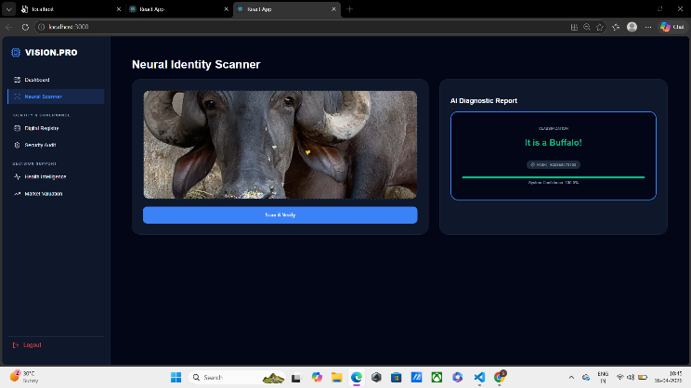
Figure C

Digital Registry and Hash ID

This module will provide the structured database of all animals that have been verified. Each record will include a Secure Hash (MD5), which is the digital fingerprint of that animal. This data will allow law enforcement to search registered livestock to ensure that no duplicates of the same identity have been created, thus maintaining the integrity of the registry.
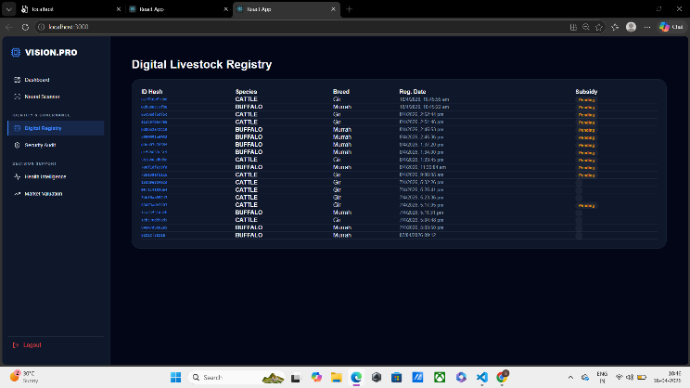

Figure D

Security Audit & Fraud Logs

While registering for accounts or attempting to register for accounts, the Security Audit page will provide a real-time defense against "Double-Subsidy Fraud" (i.e., registering an animal twice). If there is any issue related to an Identity Collision (two animals sharing the same picture) when the registration is submitted, the system will generate an alert to the officer, block the registration, and log the event for future security review.

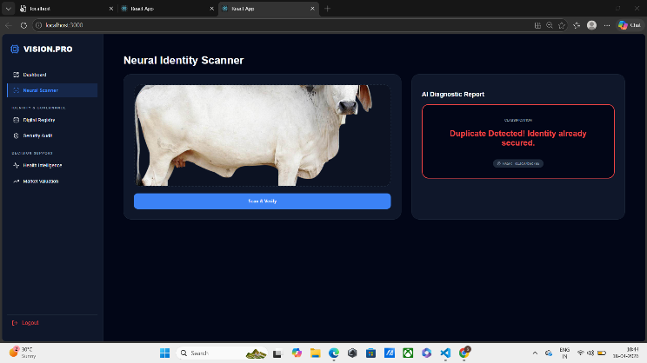

Figure E

Biological Features Identifying Basic Health Risk Indicators

Health Intelligence is defined within an organization by identifying Risk Indicators for health derived from biological features. The system will use the AI capability to evaluate Image Textures Plus Anomalies and determine if there is a probable risk factor for skin infections or injuries (e.g., nutritional problem). As a result, the health status of animals will be provided to veterinarians as soon as they see changes in the image of those animals. Consequently, the Animal Health Intelligence module gives veterinarians a proactive source of health monitoring, and therefore helping you to manage your farms more effectively.

Figure F

Dashboard for Market Analytics

The visualization module helps to plan for your farming needs. The visualization module allows you to view live counts of animals (cattle and buffalo) and their expected values. It displays this with charts and graphs using the Recharts library, providing the administrator with an overview of the livestock asset class.

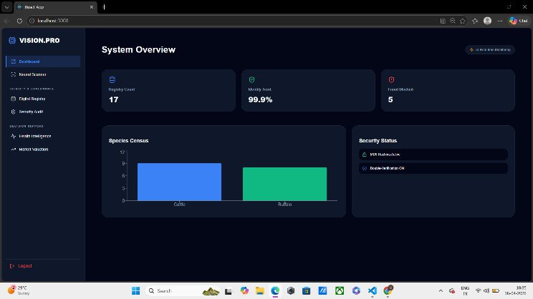

Figure G

CONCLUSION

Livestock Vision Pro offers a new way to monitor and authenticate your livestock using non-invasive Artificial Intelligence (AI). It reduces the number of mistakes and risks associated with traditional ear-tagging processes through real-time tracking, which is more accurate and secure than previous methods.
Livestock Vision Pro provides animal tracking in real-time, generating an immutable digital fingerprint (hash) via MD5 hashing. Unique records prevent double-subsidy fraud, and all data are accessible to officers who require it through a web-based platform regardless of where the officer is located (i.e., rural areas).
A significant step forward compared to existing methods is that deep learning with MobileNetV2 and TensorFlow increases transparency, efficiency, and animal welfare in agricultural governance and welfare around the world [4], [5], [14].

Acknowledgement

First of all, we want to thank the many people that have helped us through this process and guided us to a successful completion of the "Livestock Vision Pro" project. We also want to thank the Chancellor, Pro Vice Chancellor and Registrar for their ongoing support and encouragement to this project and the completion of this effort.

We would like to sincerely thank our internal mentor and project guide, Dr. Sahabzada Betab Badar (Assistant Professor at Presidency University – Computer Science and Engineering), for his support with inspirational words of encouragement and providing timely technical advice along with moral encouragement during our project work, as well as instrumental in developing our AI models and security frameworks.

Our special and deep appreciation goes to Dr. Pravinth Raja, Professor and Department Head, Presidency School of Computer Science and Engineering, for his continued leadership and academic guidance.

We wish to express our sincere appreciation to: Dr. Duraipandian N., Dean of PSCS & PSIS and Dr. Shakkeera L., Associate Dean, Presidency School of Computer Science and Engineering, with the Presidency University Management, who provided the necessary resources and intellectually stimulating environment to enable us to complete our project work.

Additionally, we express gratitude to Dr. Sampath A. K. and Dr. Geetha A. (PSCS Project Coordinators) and H. M. Manjula, Program Project Coordinator, for their assistance in developing our problem statements, organizing reviews, tracking the progress of our project, and for providing valuable support and guidance through the entire process.

References

- Bowling, M.B., et al. (2018). “Livestock Identification and Traceability: A Review.” Journal of Animal Science.

- Ruiz-Garcia, L. & Lunadei, L. (2020). “RFID Technology and Its Role in Agriculture: Past, Present, and Future.” Computers and Electronics in Agriculture.

- Awad, A.I. (2016). “Muzzle and Fingerprint Patterns: Biometric Identification Systems for Inventorying Livestock.” Pattern Recognition Letters.

- Schofield, G., et al. (2019). “AI and Deep Learning for the Identification of Animals: A New Paradigm.” Methods in Ecology and Evolution.

- Sandler, M., et al. (2018). “MobileNetV2: Inverted Residuals and Linear Bottlenecks.” IEEE Conference on Computer Vision and Pattern Recognition (CVPR).

- Kumar, S. & Singh, S.K. (2017). “Recognition of Cattle Using Muzzle Point Image Patterns.” Information Sciences.

- Santosh, K.C., et al. (2021). “Artificial Intelligence in Agriculture: Deep Learning for Livestock Monitoring.” Scientific Reports.

- Zhao, K. et al. (2020). “Automated Identification of Cows Based on Deep Learning and Facial Features.” Biosystems Engineering.

- He, K., et al. (2016). “Deep Residual Learning for Image Recognition.” Proceedings of the IEEE Conference on Computer Vision and Pattern Recognition.

- Rothe, R., et al. (2018). “Non-Invasive Biometric Identification of Buffaloes Using Convolutional Neural Networks.” Journal of Agricultural Informatics.

- Smith, J. & Taylor, R. (2021). “Cryptography: Protecting Agricultural Data from Theft.” International Journal of Information Security.

- Wang, L., et al. (2019). “Real-Time Livestock Tracking Using Edge Computing and Artificial Intelligence.” IEEE Access.

- Gupta, P. et al., 2022. To mitigate fraud in subsidies, use initial digital identity receipts: A journal-focused approach. Journal of Rural Development and Technology.

- Abinaya, S. et al., 2021. A Comparative Analysis of CNN Architectures in Mobile Agri. Applications: Soft Computing.

- FAO/UN (2023). World Livestock Report: Use Digital Innovations to Transform Livestock Industry: Food & Agriculture Organization.

